- The UK Budget presented today features a backloaded tightening of fiscal policy via a series of tax rises. Given most of the tightening is pencilled in for 2029, which is an election year, we're sceptical it will be fully implemented when the time comes.
- The policy tightening was at the lower end of expectations, reflecting smaller revisions to forecast borrowing by the Office for Budget Responsibility. As the OBR's new growth forecast is in line with the most optimistic independent forecast, we think this will store up problems for the future.
- Higher headroom for the government reduces the risk we're in the same situation next year. But the backloaded nature of the measures, the uncertain impact on revenues of many of the tax-raising measures, a lack of spending restraint, and the absence of any growth measures undermine the credibility of the package, in our view.
- The Budget measures won't trigger substantial changes to our already below-consensus GDP forecasts for the UK for 2026 and 2027. However, we think markets will gradually lose faith, and the risk of a sudden confidence crisis remains live.
Given the extensive leaking and media speculation of the past few weeks, it was quite apt that the UK's Office for Budget Responsibility accidentally leaked its own forecast more than half an hour before Chancellor Rachel Reeves stood up to present her Budget today.
Leaks aside, the general shape of the Budget was largely as expected. A combination of OBR forecast revisions, U-turns on previous policy decisions, and new spending commitments left a gap in the public finances. And the Chancellor opted to fill that gap via tax rises, with self-imposed political constraints leading her to opt to extend the tax threshold freeze and hike a variety of smaller revenue streams (Chart 1).
Chart 1: The Budget presented a backloaded package of tax rises
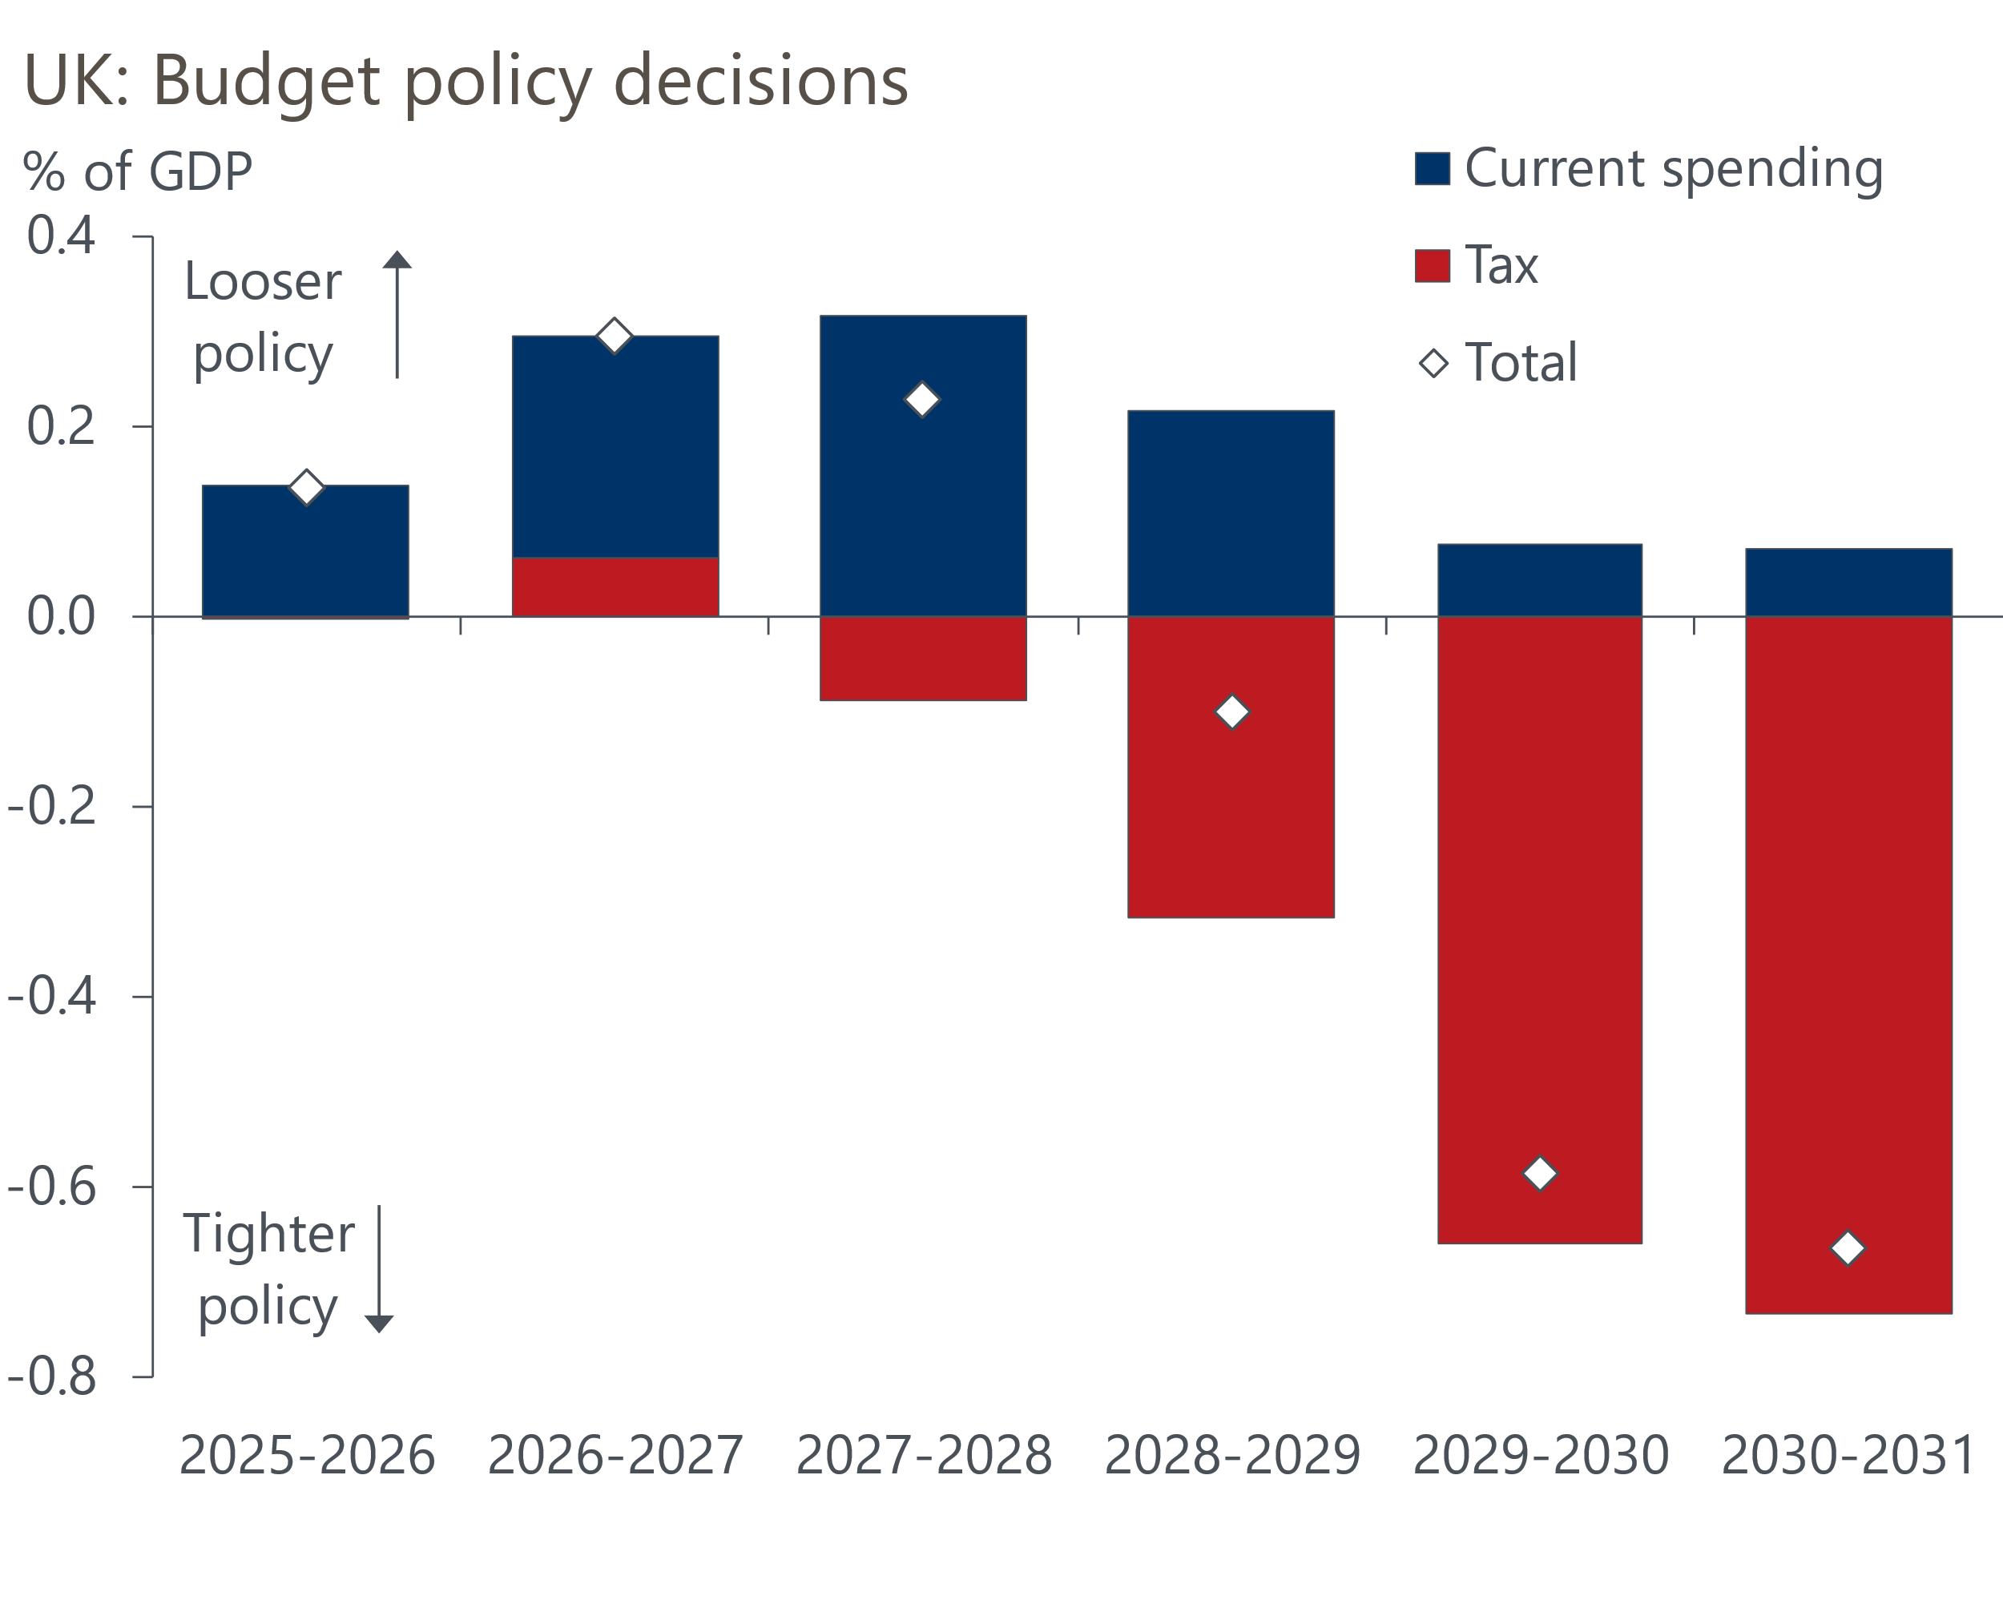
Sources: HM Treasury

Surprisingly, the revisions to the OBR's borrowing forecast were smaller than most expected. This meant the Chancellor could implement a tightening package at the lower end of expectations: £21bn or 0.6% of GDP in 2029-2030, the target year for the fiscal rules, building to £24bn the following year. Reeves also increased the amount of headroom to a much healthier £22bn (0.6% of GDP) – more than double the margin for error in the spring statement last March.

The OBR's lower growth forecast still looks too optimistic
In our recent preview, we had predicted that the OBR would make a large downgrade to its forecast for GDP over the medium-term, but that the impact on the fiscal projections would be mitigated by stronger forecasts for pay growth and inflation. In the event, the balance of those revisions was more favourable to the government than we had anticipated. And though the OBR also upgraded its estimates of the cost of administering the welfare system, its pre-measures forecast still showed the government narrowly complying with its fiscal rules.
In March, the official forecaster had projected stronger GDP growth over the next five years than any independent forecaster. But it belatedly acknowledged that its assumptions for productivity growth were too bullish. Today's revisions narrow the gap with our forecast (Chart 2), but we still think the OBR is overcooking growth.
Chart 2: The OBR's forecasts look more reasonable, but are still higher than our projections
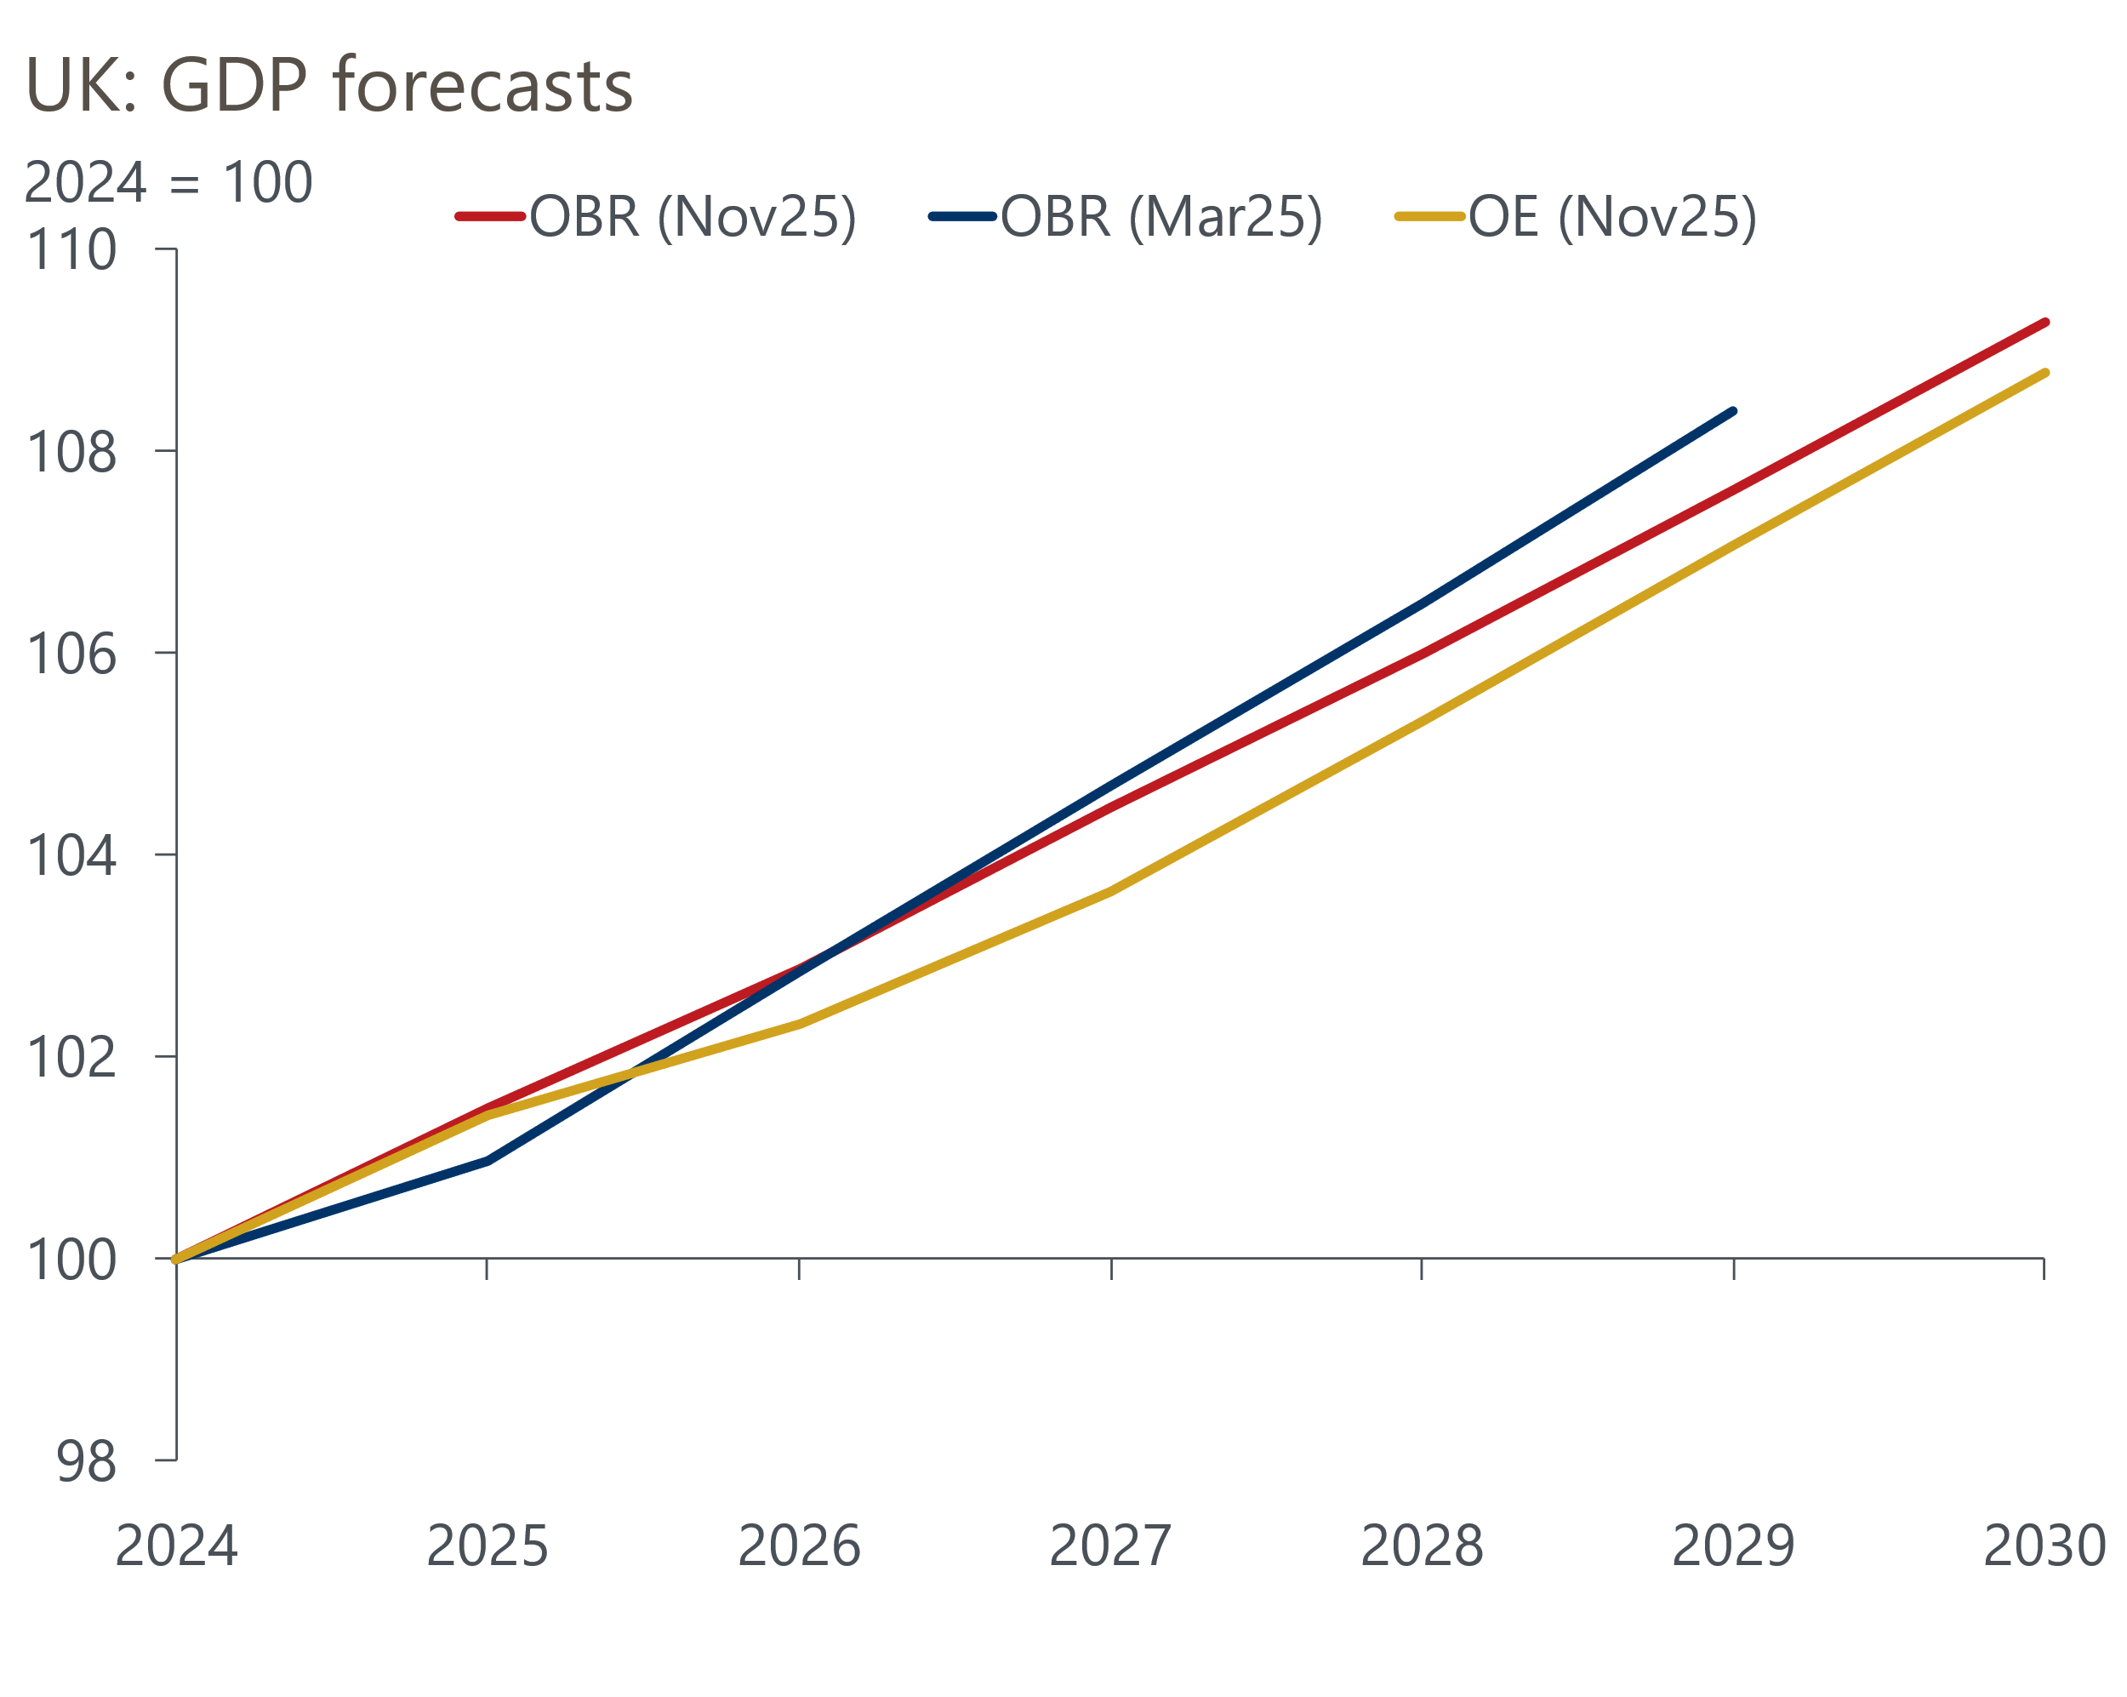
Sources: Oxford Economics, Office for Budget Responsibility
Its new forecast is in line with the most optimistic forecast of the consensus; we think the official forecasts should be based on a more conservative, consensus, view. In our view, erring on the bright side just stores up problems for the future, and another growth downgrade is likely at some point.
What's more, the evidence to back the productivity downgrade has been there for several years, and today's revision should have come much sooner.

Policy choices undermine credibility
At the past two fiscal events, we were highly critical of the Chancellor leaving such little headroom – we felt this was a key factor behind the volatile fiscal policy environment. So today's decision to more than double the amount of headroom sounds sensible to us, although the margin for error is still a little lower than the average of fiscal events since 2010. Still, it should reduce the risk we are back in the same situation in a years' time.
On the other hand, four other decisions risk undermining the credibility of her fiscal approach. First, the new policy measures announced today are backloaded, dragging out the consolidation over a long period (Chart 3). There's a £17bn (0.5% of GDP) tightening in fiscal year 2029-2030 alone, a year when the next general election is due to take place.
The bulk of the savings come from extending the tax threshold freeze and limiting the generosity of salary sacrifice, and there's likely to be a temptation to delay or even abandon those measures as the election nears, particularly given the target year for the fiscal rules will be moving out again by then.
Chart 3: The fiscal consolidation will be dragged out over a long period
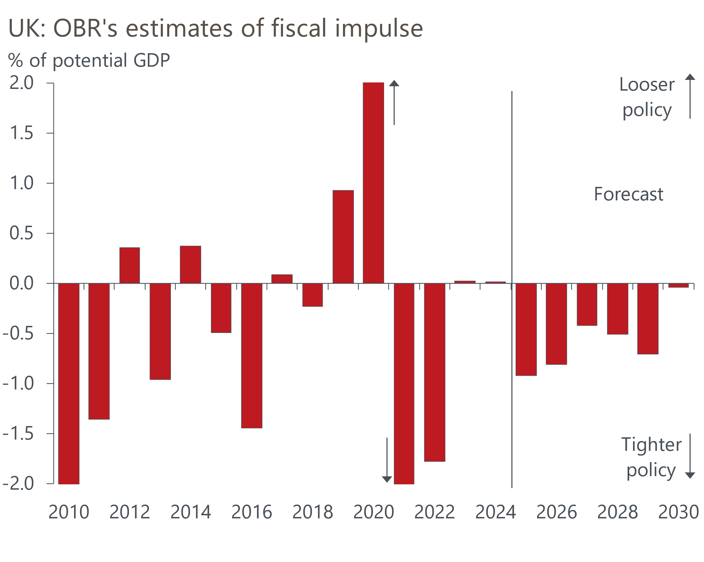
Source: Oxford Economics calculations using data from Office for Budget Responsibility
Second, apart from the extension of the threshold freeze, the tax measures encompass a wide variety of large increases to smaller revenues streams. Such changes often trigger behavioural change, so revenue projections are more speculative. And as the experience of the October 2024 Budget demonstrates, they tend to result in specific groups being hit particularly hard, which can sometimes make the measures politically unsustainable.
Third, the Chancellor made no attempt to restrain spending, apart from the inclusion of some unspecified "efficiency savings" in the last two years of the forecast. Indeed, the OBR forecasts show the spending-to-GDP ratio rising throughout the forecast period, placing all the burden on tax hikes. History suggests that revenue-based consolidations have a higher risk of failure. They also risk adding to the perception that the government lacks the internal discipline to cut spending.
Fourth, any supply-side reforms or other measures to boost growth were strikingly absent. We've been underwhelmed by the measures announced by the government over the past year. And considering the Chancellor has been keen to talk up her attempts to drag the UK out of its low-growth rut, the absence of any substantive policies raises questions about whether she has a well-developed strategy.

The Budget won't lead to major changes to our forecasts
The backloaded nature of the policy measures means that we don't plan to make major changes to our already-below consensus near-term GDP forecast for the UK in our next update on December 8.
We don’t think the Budget materially changes the outlook for monetary policy either. The Monetary Policy Committee is likely to cut rates again at one of the next two meetings – we slightly favour December.
Meanwhile, the immediate financial market reaction has been positive, with the 10-year gilt yield falling and sterling strengthening a little. This likely reflects the additional headroom in the new plans.
Still, although the initial response has been positive, we think that confidence will dwindle as markets question the credibility of the government's commitments to tighten policy just before the next election, and whether behavioural changes will prevent the tax rises from generating enough of a revenue uplift.
Our baseline forecast is that this will result in a slow burn of rising risk premia and a falling pound. That could morph into a more sudden loss of confidence, given a set of unfavourable surprises, so the downside scenario that we outlined last month remains a live risk.

